**Sprint 2 Plan**

**UCSC Academic Planner, April 28th 2023**

**Goal**

* Enhance and create more frontend of the planner to create more options for the user. Show list of required courses for major, GE requirements, credits taken per quarter, and be able to generate a schedule for stem majors.

**User Stories**

* 2.1 I am someone interested in UCSC and want to see a list of required courses for majors. [3]

# Finish adding all departments and majors to the webpage.

# Implement proper dropdown boxes on the website .

# Get Started on web scraping the major requirements page

# Add logic for generating planner based on major

# Set up database

* 2.2 I am a UCSC student and I want to see if I fulfill all GE/major requirements to declare[3]

# Finish web scraping course catalog requirements and prerequisites

* + Get Started on web scraping the major requirements page
* 2.3 I want to see how many credits I’m taking per quarter. [1]

# Finish web scraping course catalog requirements and prerequisites

* + Finish frontend credit counter
* 2.4 I am a STEM major at UCSC and I want to generate a schedule [1]

# Get frontend planner implemented

**Team Roles**

Betros Abraha (Product Owner)

Jin Lee

Brandan Fong (Scrum Master)

Sean Carlyle

Michelle Hernandez

**Task Assignment**

Betros Abraha: User story 2.1

Jin Lee: User story 2.4

Brandan Fong: User story 2.1

Sean Carlyle: User story 2.2

Michelle Hernandez: User story 2.4

**Initial Burnup Chart**

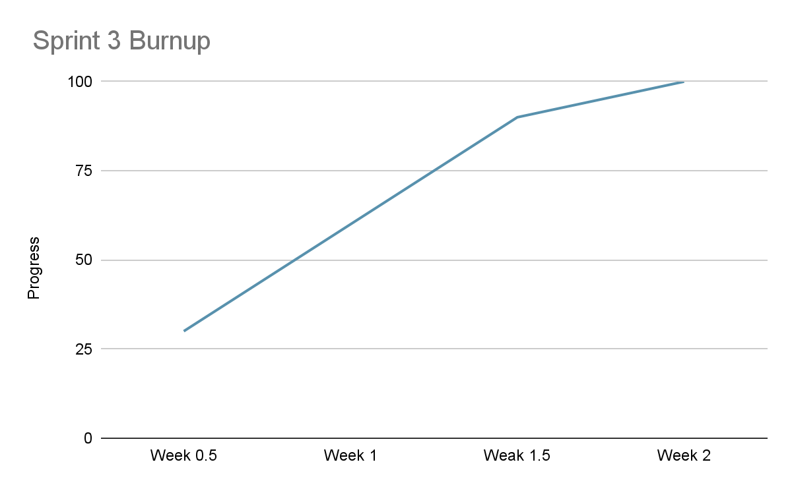

**Initial Scrum Board**

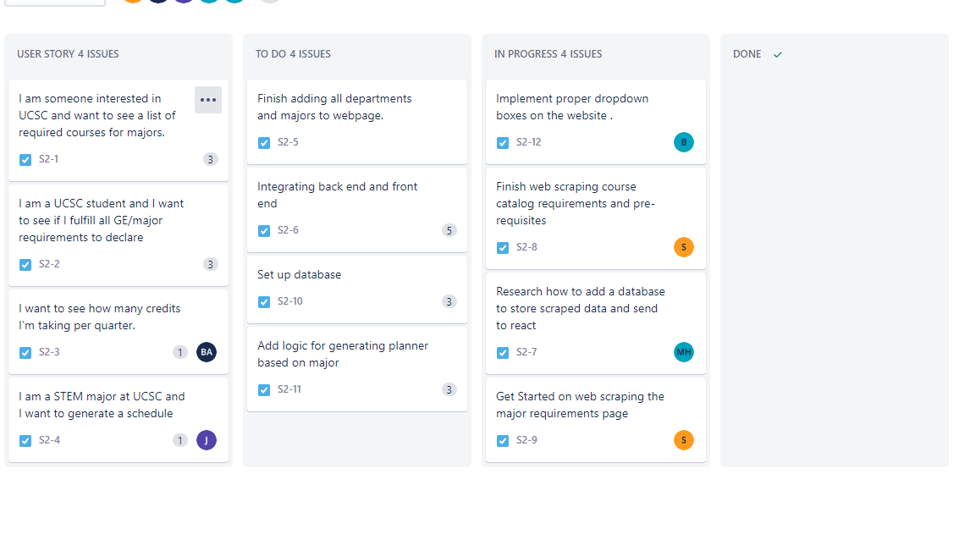

| **User stories** | **Tasks not started** | **Tasks in progress** | **Tasks completed** |
| --- | --- | --- | --- |
| 4 | 4 | 5 | 0 |

**Scrum Times**

Meeting MF 9:05am

TA meeting: W 4:45pm